

DSA0602-DATA HANDLING AND DATA VISUALIZATION
SLOT A
Dr.ALMAS BEGUM
PRESENTED BY:
SURU SAI KEERTHI [192424368]
Class Activity: 10.07.2026
Scenario 1: Student Academic Performance Dashboard
Learning Outcome
Understand how position and color aesthetics represent different data types.
Scenario
The Head of the Computer Science Department wants to analyze whether students with higher
attendance perform better in examinations. The department also wants to compare the
performance across different programs.
Dataset
• Student ID
• Attendance (%)
• Internal Marks
• Department (CSE, AI, IT, ECE)
Student Task
• Identify quantitative and categorical variables.
• Map Attendance to the X-axis.
• Map Marks to the Y-axis.
• Represent the Department using different colors.
• Add an appropriate title, labels, and legend.
CODE:
import pandas as pd
import matplotlib.pyplot as plt

# Student Dataset
data = {
"Student ID": [101, 102, 103, 104, 105, 106, 107, 108, 109, 110],
"Attendance": [72, 85, 91, 65, 96, 88, 78, 82, 69, 94],
"Internal Marks": [68, 79, 91, 60, 95, 87, 73, 81, 66, 93],
"Department": ["CSE", "AI", "IT", "ECE", "CSE", "AI", "IT", "ECE", "CSE", "AI"]
}

df = pd.DataFrame(data)

# Create Figure
plt.figure(figsize=(10,6))

# Plot department-wise
for dept in df["Department"].unique():

dept_data = df[df["Department"] == dept]

plt.scatter(
dept_data["Attendance"],
dept_data["Internal Marks"],
s=120
)

# Label each point
for i in range(len(dept_data)):
plt.text(
dept_data["Attendance"].iloc[i] + 0.3,
dept_data["Internal Marks"].iloc[i] + 0.3,
f"({dept_data['Student ID'].iloc[i]}, {dept})",
fontsize=8
)

# Title and Labels
plt.title("Student Academic Performance Dashboard", fontsize=16)
plt.xlabel("Attendance (%)", fontsize=12)
plt.ylabel("Internal Marks", fontsize=12)

# Grid
plt.grid(True, linestyle="--", alpha=0.5)

# Display Graph
plt.show()

OUTPUT:
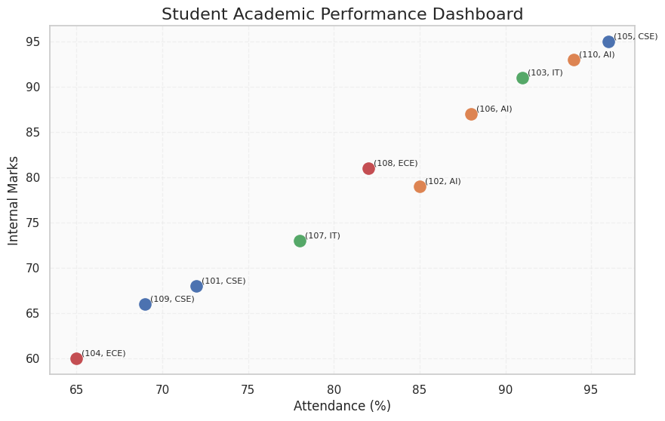

Scenario 2: Electric Vehicle Market Analysis
Learning Outcome
Learn how size and color aesthetics can simultaneously represent multiple variables.
Scenario
An automobile company is studying the relationship between battery capacity and vehicle price
to understand whether larger batteries significantly increase the selling price.
Dataset
• Vehicle Model
• Battery Capacity (kWh)
• Price
• Driving Range
• Manufacturer
Student Task
• Plot Battery Capacity against Price.
• Use Driving Range as bubble size.
• Use Manufacturer as color.
• Interpret whether larger batteries correspond to higher prices.
CODE:
import pandas as pd
import matplotlib.pyplot as plt

# EV Dataset
data = {
"Vehicle Model": ["Nexon EV", "MG ZS EV", "Kona EV", "Atto 3", "Model 3",
"XUV400", "Punch EV", "Ioniq 5"],
"Battery Capacity": [30, 50, 39, 60, 75, 40, 35, 72],
"Price": [15, 24, 23, 34, 55, 18, 14, 46],
"Driving Range": [325, 461, 452, 521, 614, 375, 421, 631],
"Manufacturer": ["Tata", "MG", "Hyundai", "BYD",
"Tesla", "Mahindra", "Tata", "Hyundai"]
}

df = pd.DataFrame(data)

plt.figure(figsize=(10,6))

# Bubble Chart
plt.scatter(
df["Battery Capacity"],
df["Price"],
s=df["Driving Range"],
c=range(len(df)),
cmap="viridis",
alpha=0.8,
edgecolors="black"
)

# Label every bubble
for i in range(len(df)):
plt.text(
df["Battery Capacity"][i] + 0.5,
df["Price"][i] + 0.2,
f"({df['Vehicle Model'][i]}, {df['Manufacturer'][i]})",
fontsize=8
)

plt.title("Electric Vehicle Market Analysis", fontsize=16)
plt.xlabel("Battery Capacity (kWh)", fontsize=12)
plt.ylabel("Price (Lakhs ₹)", fontsize=12)

plt.grid(True, linestyle="--", alpha=0.5)

plt.show()
OUTPUT:
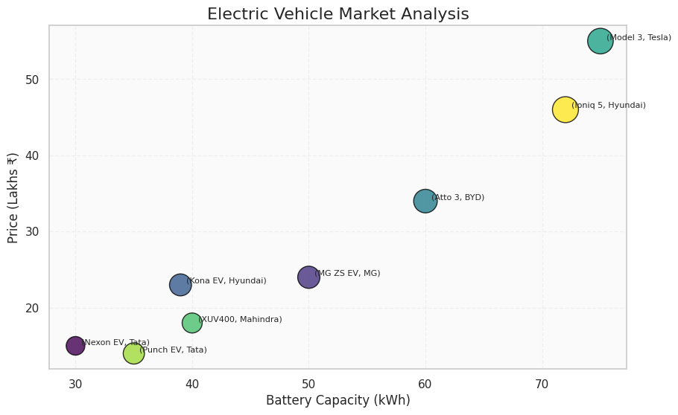

Scenario 3: Hospital Patient Admission Analysis
Learning Outcome
Visualize categorical variables using fill color and position aesthetics.
Scenario
A hospital administrator wants to compare patient admissions across departments during the
last month.
Dataset
• Department
• Number of Patients
• Average Treatment Cost
Student Task
• Create a bar chart.

• Use different fill colors for each department.
• Display treatment cost as labels on the bars.

CODE:
import pandas as pd
import matplotlib.pyplot as plt

# Hospital Dataset
data = {
"Department": ["Cardiology", "Neurology", "Orthopedics", "Pediatrics", "Oncology"],
"Number of Patients": [120, 95, 150, 110, 85],
"Average Treatment Cost": [50000, 65000, 40000, 30000, 70000]
}

df = pd.DataFrame(data)

# Create Figure
plt.figure(figsize=(10,6))

# Bar Chart
bars = plt.bar(
df["Department"],
df["Number of Patients"]
)

# Display Treatment Cost on Bars
for i in range(len(df)):
plt.text(
i,
df["Number of Patients"][i] + 3,
f"₹{df['Average Treatment Cost'][i]}",
ha="center",
fontsize=9
)

# Title and Labels
plt.title("Hospital Patient Admission Analysis", fontsize=16)
plt.xlabel("Department", fontsize=12)
plt.ylabel("Number of Patients", fontsize=12)

# Grid
plt.grid(axis="y", linestyle="--", alpha=0.5)

plt.show()
OUTPUT:
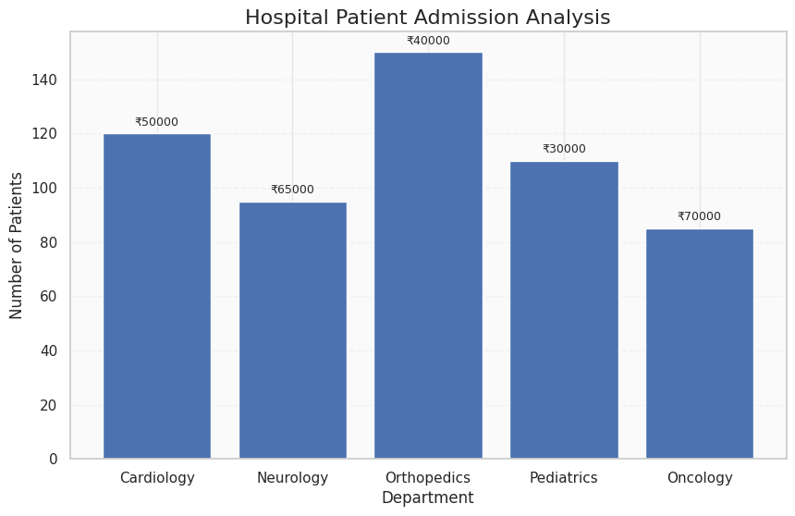

Scenario 4: Weather Monitoring System
Learning Outcome
Understand how line type and color distinguish multiple categories.
Scenario
The Indian Meteorological Department has collected daily temperature data for three cities
over one month and wants to compare climate trends.
Dataset
• Date
• Temperature
• City
Student Task
• Draw a line chart.
• Use different colors for each city.
• Use different line styles for each city.
• Compare temperature trends.
CODE:
import pandas as pd
import matplotlib.pyplot as plt

# Weather Dataset
data = {
"Day": [1,2,3,4,5,6,7],
"Chennai": [34,35,36,35,37,38,37],
"Bangalore": [28,29,30,29,31,30,29],
"Hyderabad": [32,33,34,35,34,36,35]
}

df = pd.DataFrame(data)

plt.figure(figsize=(10,6))

# Chennai
plt.plot(df["Day"], df["Chennai"],
color="blue",
linestyle="-",
marker="o",
linewidth=2)

for i in range(len(df)):
plt.text(df["Day"][i], df["Chennai"][i]+0.2,
f"({df['Day'][i]}, {df['Chennai'][i]})",
fontsize=8)

# Bangalore
plt.plot(df["Day"], df["Bangalore"],
color="green",
linestyle="--",
marker="s",
linewidth=2)

for i in range(len(df)):
plt.text(df["Day"][i], df["Bangalore"][i]-0.8,
f"({df['Day'][i]}, {df['Bangalore'][i]})",
fontsize=8)

# Hyderabad
plt.plot(df["Day"], df["Hyderabad"],
color="red",
linestyle=":",
marker="^",
linewidth=2)

for i in range(len(df)):
plt.text(df["Day"][i], df["Hyderabad"][i]+0.6,
f"({df['Day'][i]}, {df['Hyderabad'][i]})",
fontsize=8)

# Title and Labels
plt.title("Weather Monitoring System", fontsize=16)
plt.xlabel("Day", fontsize=12)
plt.ylabel("Temperature (°C)", fontsize=12)

plt.grid(True, linestyle="--", alpha=0.5)

plt.show()

OUTPUT:

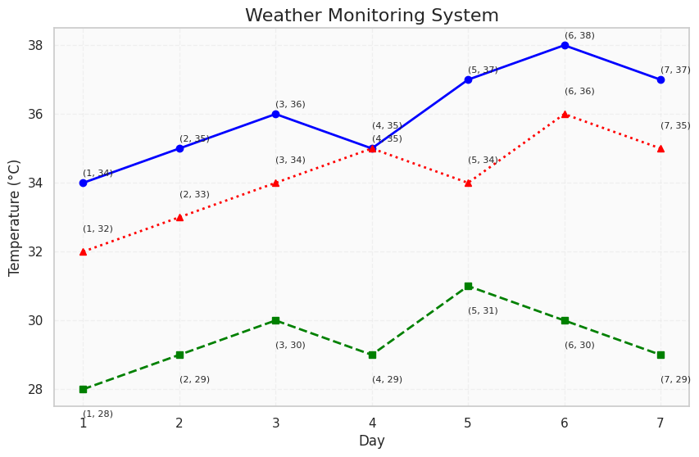

Scenario 5: Supermarket Sales Analysis
Learning Outcome
Apply position and fill aesthetics for grouped comparisons.
Scenario
A supermarket chain wants to identify which product categories generate the highest monthly
sales across different branches.
Dataset
• Month
• Product Category
• Sales Amount
• Branch

Student Task
• Create grouped bar charts.
• Use branch as fill color.
• Compare product sales among branches.
CODE:
import pandas as pd
import matplotlib.pyplot as plt
import numpy as np

# Supermarket Dataset
data = {
"Product Category": ["Groceries", "Beverages", "Snacks", "Personal Care"],
"Branch A": [50000, 35000, 28000, 22000],
"Branch B": [55000, 32000, 30000, 25000],
"Branch C": [48000, 37000, 26000, 21000]
}

df = pd.DataFrame(data)

# X-axis positions
x = np.arange(len(df["Product Category"]))
width = 0.25

plt.figure(figsize=(10,6))

# Grouped Bars
bar1 = plt.bar(x - width, df["Branch A"], width, label="Branch A")
bar2 = plt.bar(x, df["Branch B"], width, label="Branch B")
bar3 = plt.bar(x + width, df["Branch C"], width, label="Branch C")

# Labels on Bars
for bar in bar1:
plt.text(
bar.get_x() + bar.get_width()/2,
bar.get_height() + 500,
f"(A,{int(bar.get_height())})",
ha="center",
fontsize=8
)

for bar in bar2:
plt.text(
bar.get_x() + bar.get_width()/2,
bar.get_height() + 500,
f"(B,{int(bar.get_height())})",
ha="center",
fontsize=8
)

for bar in bar3:
plt.text(
bar.get_x() + bar.get_width()/2,
bar.get_height() + 500,
f"(C,{int(bar.get_height())})",
ha="center",
fontsize=8
)

# Axis Labels
plt.xticks(x, df["Product Category"])
plt.xlabel("Product Category", fontsize=12)
plt.ylabel("Sales Amount (₹)", fontsize=12)

# Title
plt.title("Supermarket Sales Analysis", fontsize=16)

# Legend
plt.legend(title="Branch")

# Grid
plt.grid(axis="y", linestyle="--", alpha=0.5)

plt.show()

OUTPUT:
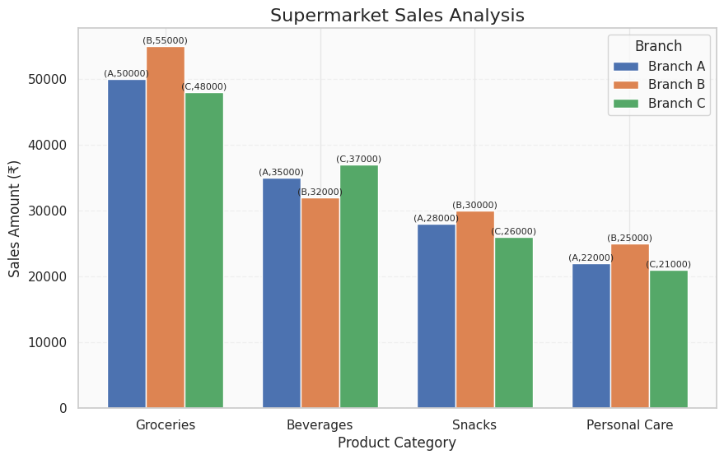

Scenario 6: Employee Salary Distribution
Learning Outcome
Understand continuous scales and histogram binning.
Scenario
The HR department wants to understand salary distribution among employees to determine
whether salaries are evenly distributed across the organization.
Dataset
• Employee ID
• Salary
• Experience
• Department
Student Task
• Create a histogram of salaries.
• Experiment with different bin sizes.
• Compare the effect of changing the scale.
CODE:
import matplotlib.pyplot as plt

# Employee Salary Dataset (in ₹)
salary = [
25000,28000,30000,32000,35000,
37000,40000,42000,45000,47000,
50000,52000,55000,58000,60000,
62000,65000,68000,70000,72000,
75000,78000,80000,82000,85000,
88000,90000,92000,95000,98000
]

# Histogram with 10 Bins
plt.figure(figsize=(8,5))
plt.hist(salary, bins=10, edgecolor="black")
plt.title("Employee Salary Distribution (10 Bins)", fontsize=15)
plt.xlabel("Salary (₹)", fontsize=12)
plt.ylabel("Number of Employees", fontsize=12)
plt.grid(axis="y", linestyle="--", alpha=0.5)
plt.show()

# Histogram with 20 Bins
plt.figure(figsize=(8,5))
plt.hist(salary, bins=20, edgecolor="black")
plt.title("Employee Salary Distribution (20 Bins)", fontsize=15)
plt.xlabel("Salary (₹)", fontsize=12)
plt.ylabel("Number of Employees", fontsize=12)
plt.grid(axis="y", linestyle="--", alpha=0.5)
plt.show()

OUTPUT:

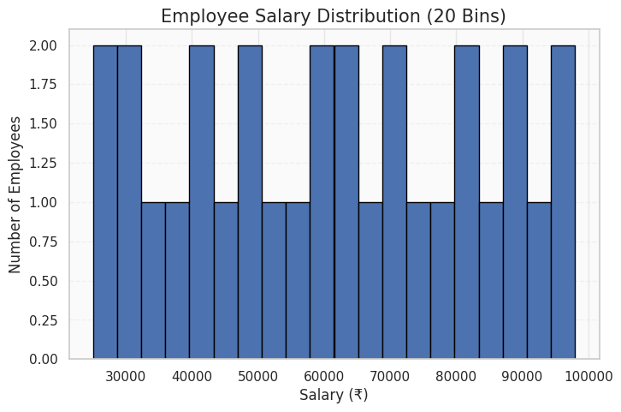

Scenario 7: Smartphone Market Comparison
Learning Outcome
Map multiple variables using shape, size, and color.
Scenario
A technology company wants to compare smartphone specifications to understand how RAM
and processor speed influence product pricing.
Dataset
• Brand
• RAM

• Processor Speed
• Price
• Storage
Student Task
• Plot RAM against Price.
• Represent Brand using shapes.
• Represent Storage using point size.
• Use color to indicate Processor Speed.
CODE:
import pandas as pd
import matplotlib.pyplot as plt

# Smartphone Dataset
data = {
"Brand": ["Samsung", "Apple", "OnePlus", "Xiaomi", "Realme", "Vivo"],
"RAM": [8, 6, 12, 8, 16, 12],
"Processor Speed": [2.4, 3.2, 3.0, 2.8, 3.1, 2.9],
"Price": [35000, 75000, 50000, 28000, 45000, 38000],
"Storage": [128, 256, 256, 128, 512, 256]
}

df = pd.DataFrame(data)

# Marker for each Brand
markers = {
"Samsung": "o",
"Apple": "s",
"OnePlus": "^",
"Xiaomi": "D",
"Realme": "P",
"Vivo": "*"
}

plt.figure(figsize=(10,6))

# Plot each brand
for brand in df["Brand"].unique():

brand_data = df[df["Brand"] == brand]

scatter = plt.scatter(
brand_data["RAM"],
brand_data["Price"],
s=brand_data["Storage"], # Point Size
c=brand_data["Processor Speed"], # Color
cmap="viridis",
marker=markers[brand],
edgecolors="black",
label=brand
)

# Label every point
for i in range(len(brand_data)):
plt.text(
brand_data["RAM"].iloc[i] + 0.1,
brand_data["Price"].iloc[i] + 500,
f"({brand},{brand_data['Storage'].iloc[i]}GB)",
fontsize=8
)

# Color Bar
plt.colorbar(scatter, label="Processor Speed (GHz)")

# Labels
plt.title("Smartphone Market Comparison", fontsize=16)
plt.xlabel("RAM (GB)", fontsize=12)
plt.ylabel("Price (₹)", fontsize=12)

# Legend
plt.legend(title="Brand")

# Grid
plt.grid(True, linestyle="--", alpha=0.5)

plt.show()

OUTPUT:
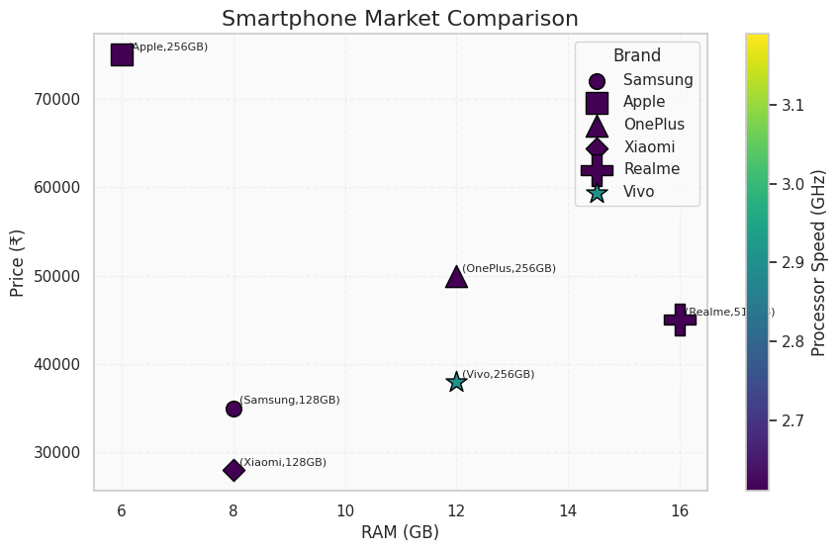

Scenario 8: Online Movie Rating Analysis
Learning Outcome
Understand continuous color scales and gradient aesthetics.
Scenario
A movie streaming platform wants to compare average ratings received by different movie
genres over the past year.
Dataset
• Genre
• Average Rating
• Number of Reviews
• Release Year
Student Task
• Create a heatmap.
• Represent ratings using a color gradient.
• Identify the highest-rated genres.
CODE:
import pandas as pd
import matplotlib.pyplot as plt
import seaborn as sns

# Movie Dataset
data = {
"Genre": ["Action", "Comedy", "Drama", "Horror", "Sci-Fi"],
"2021": [4.2, 3.8, 4.5, 3.6, 4.7],
"2022": [4.3, 3.9, 4.6, 3.8, 4.8],
"2023": [4.5, 4.0, 4.7, 3.9, 4.9],
"2024": [4.6, 4.1, 4.8, 4.0, 5.0]
}

df = pd.DataFrame(data)

# Set Genre as index
heatmap_data = df.set_index("Genre")

# Create Heatmap
plt.figure(figsize=(8,5))

sns.heatmap(
heatmap_data,
annot=True,
cmap="YlGnBu",
linewidths=1,
linecolor="white",
cbar_kws={"label": "Average Rating"}
)

# Title and Labels
plt.title("Online Movie Rating Analysis", fontsize=16)
plt.xlabel("Release Year", fontsize=12)
plt.ylabel("Genre", fontsize=12)

plt.show()

OUTPUT:
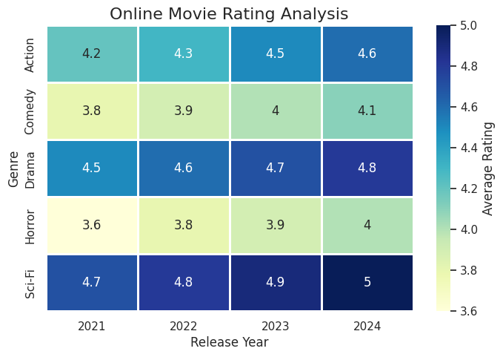

Scenario 9: COVID-19 State-wise Analysis
Learning Outcome
Understand sequential, diverging, and categorical color scales.
Scenario

The Ministry of Health wants to visualize the distribution of COVID-19 cases across different
Indian states to identify highly affected regions.
Dataset
• State
• Active Cases
• Vaccination Percentage
• Population
Student Task
• Create a choropleth map (or tile plot if maps are unavailable).
• Represent Active Cases using a sequential color scale.
• Compare the intensity across states.
CODE:
import pandas as pd
import matplotlib.pyplot as plt
import seaborn as sns

# COVID-19 Dataset
data = {
"State": [
"Tamil Nadu",
"Kerala",
"Karnataka",
"Maharashtra",
"Delhi",
"Telangana",
"Andhra Pradesh",
"Gujarat"
],
"Active Cases": [3200, 4500, 2800, 6200, 1800, 2100, 2600, 3000],
"Vaccination (%)": [94, 96, 92, 91, 95, 93, 90, 89],
"Population (Millions)": [78, 36, 69, 126, 20, 40, 54, 71]
}

df = pd.DataFrame(data)

# Create Tile Plot (Heatmap)
heatmap_data = df.set_index("State")[["Active Cases"]]

plt.figure(figsize=(8,6))

sns.heatmap(
heatmap_data,
annot=True,
cmap="Reds",
linewidths=1,
linecolor="white",
cbar_kws={"label": "Active Cases"}
)

plt.title("COVID-19 State-wise Analysis", fontsize=16)
plt.xlabel("")
plt.ylabel("State", fontsize=12)

plt.show()
OUTPUT:
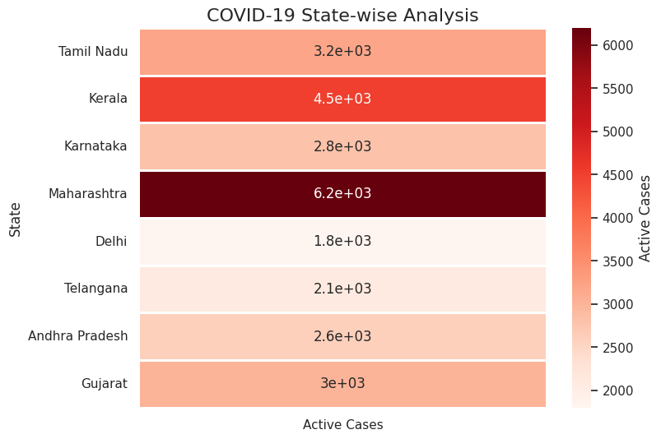

Scenario 10: Iris Flower Classification
Learning Outcome
Understand how multiple aesthetic mappings improve pattern recognition and class
separation.
Scenario
A botanist wants to analyze flower measurements to determine whether different Iris species
can be visually separated.
Dataset
(Built-in Iris Dataset)
• Sepal Length
• Sepal Width
• Petal Length
• Petal Width
• Species
Student Task
• Plot Sepal Length against Petal Length.
• Use Species as color.
• Use Species as shape.

• Use Sepal Width as point size.
• Interpret whether species form distinct clusters.
CODE:
from sklearn.datasets import load_iris
import pandas as pd
import matplotlib.pyplot as plt

# Load Iris Dataset
iris = load_iris()

# Create DataFrame
df = pd.DataFrame(
iris.data,
columns=[
"Sepal Length",
"Sepal Width",
"Petal Length",
"Petal Width"
]
)

df["Species"] = iris.target
df["Species"] = df["Species"].map({
0: "Setosa",
1: "Versicolor",
2: "Virginica"
})

# Marker styles
markers = {
"Setosa": "o",
"Versicolor": "s",
"Virginica": "^"
}

plt.figure(figsize=(10,6))

# Plot each species
for species in df["Species"].unique():

species_data = df[df["Species"] == species]

plt.scatter(
species_data["Sepal Length"],
species_data["Petal Length"],
s=species_data["Sepal Width"] * 50, # Point Size
c=species_data["Petal Width"], # Color
cmap="viridis",
marker=markers[species],
edgecolors="black",
label=species
)

# Label every point
for i in range(len(df)):
plt.text(
df["Sepal Length"][i] + 0.02,
df["Petal Length"][i] + 0.02,
df["Species"][i],
fontsize=6
)

# Color Bar
plt.colorbar(label="Petal Width (cm)")

# Title and Labels
plt.title("Iris Flower Classification", fontsize=16)
plt.xlabel("Sepal Length (cm)", fontsize=12)
plt.ylabel("Petal Length (cm)", fontsize=12)

# Legend
plt.legend(title="Species")

# Grid
plt.grid(True, linestyle="--", alpha=0.5)

plt.show()
OUTPUT:
